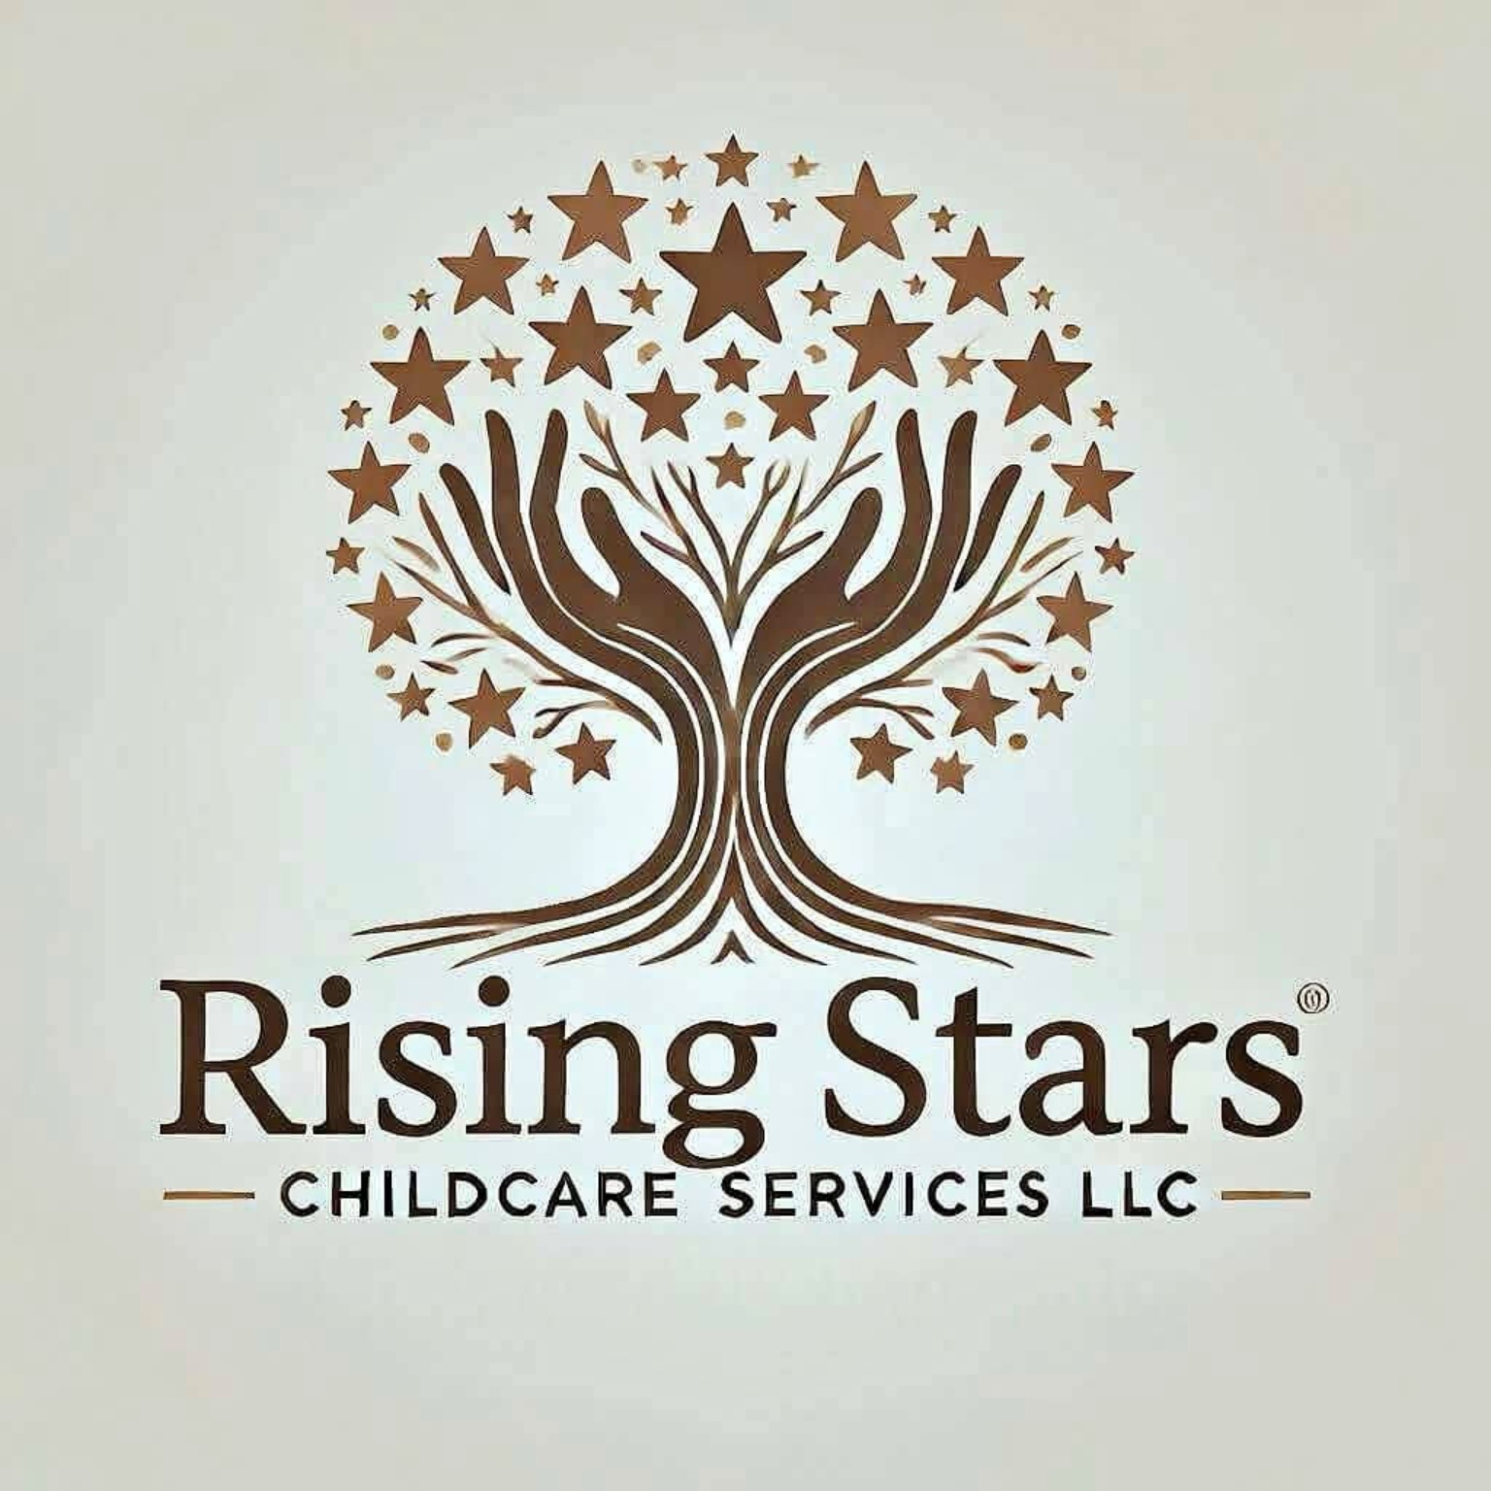
PARENT HANDBOOK & FAMILY POLICIES
Rising Stars Childcare Services LLC
Lynn, Massachusetts | 2026-2027
Effective September 14, 2026

Welcome to Rising Stars
Thank you for considering Rising Stars Childcare Services LLC to care for and educate your child. Rising Stars is an EEC-licensed family child care program committed to safe, nurturing, dependable, developmentally appropriate care and a strong partnership with families.
Our goal is to support the whole child - including self-help skills, social-emotional development, physical wellness, curiosity, language, early academics and school readiness - through hands-on, play-based and engaging experiences.

1. Provider & Program Information
Item | Information
Program | Rising Stars Childcare Services LLC
Provider | Nicole McClain
License | EEC Family Child Care - License #9180470
Location | Lynn, Massachusetts
Hours | Monday-Friday, 6:00 a.m.-6:00 p.m.
Contracted care | Families select regular arrival and departure times within program hours.
Initial enrollment model | Up to six children in care, subject to EEC capacity and age/ratio requirements.
EEC Licensor | Eileen Carranza | (781) 605-4085 | eileen.carranza@mass.gov

Provider Qualifications
- EEC Lead Teacher certifications in Preschool and Infant/Toddler and Director I & II certification.
- Bachelor's degree with an Early Childhood Education Administration focus.
- Master's degree in Educational Leadership & Policy from Boston College.
- Experience in center-based and family child care settings.
- United States Army National Guard veteran.
Rising Stars maintains business liability insurance and complies with applicable EEC licensing and background-record-check requirements.

2. Family Partnership & Records
Families and the provider will communicate regularly about each child's physical, emotional, social and intellectual development. Families should promptly share changes in schedules, routines, home circumstances, allergies, health needs, toileting, eating, sleep, special instructions, IEPs or other plans that affect care.
- Keep emergency contacts, physician/dentist information and authorized pickup persons current.
- Provide completed enrollment, emergency medical/dental consent and required health records.
- Provide updated immunization and health documentation as required by EEC.
- Respect the privacy of other enrolled families and the provider's household.

3. Tuition, Fees & Contracted Schedules
A child's contracted schedule reserves a specific space in the program. Regular enrollment requires a minimum of two contracted days per week unless otherwise agreed in writing. Requests to switch days or add care are subject to licensed capacity and availability.
Private-Pay Option | Schedule | 2026-2027 Rate
Short Day | Up to 6 hours | $80/day
Standard Day | More than 6, up to 10 hours | $120/day
Extended Day | More than 10, up to 12 hours | $150/day
Drop-in Care | When available and approved in advance | $15/hour

Tuition is paid one week in advance unless another written arrangement is made. Tuition reserves the child's space and remains due when a private-pay child is absent because of illness, family vacation, appointments or other family choice. Approved paid program closure days are also built into private-pay tuition.

Late or Failed Payments
If tuition is not paid when due, care may be suspended until the account is brought current. An insufficient-funds or returned-payment fee of $25 plus any bank or processing charges incurred by the program may be assessed.

Early Drop-Off & Late Pickup
Families must follow their contracted arrival and departure times. Early arrival or extended care must be approved in advance and is subject to availability.
Rising Stars closes at 6:00 p.m. A child is considered late when the child remains in care beyond the contracted pickup time without prior approval.
Late pickup fee: $2 per minute beginning 5 minutes after the contracted pickup time. The late fee is due promptly and is not an optional way to purchase additional care. Repeated late pickups may result in a required schedule change or termination of care.
If a parent/guardian cannot be reached, Rising Stars will contact authorized emergency pickup persons. If no responsible adult can be reached within one hour, the provider will follow applicable EEC requirements and contact appropriate authorities if necessary to protect the child.

4. Child Care Financial Assistance (Voucher) Families
Rising Stars will participate in Massachusetts Child Care Financial Assistance (CCFA) through Child Care Circuit. Voucher enrollment, attendance, parent fees, reimbursement, absences and approved closures will be administered according to the family's active authorization and current EEC/CCFA requirements.
- Voucher-funded care cannot begin before the authorization start date.
- Parent fees will be collected only as assessed and permitted under EEC policy.
- Voucher families will not be charged a voucher parent fee for an approved closure day when EEC covers that fee.
- A private-pay arrangement before or after a voucher authorization requires a separate written agreement.
- Rising Stars will not deny, discourage or terminate enrollment solely because a family receives a subsidy.

5. Arrival, Departure & Authorized Pickup
Parents/guardians should notify Rising Stars as soon as possible when a child will be absent, significantly late, or picked up by someone different from the usual authorized person. Children will be released only to a parent/guardian or another person authorized in writing, subject to EEC requirements.

6. Program Closures, Holidays & Backup Care
Rising Stars maintains an annual closure calendar. Families are responsible for arranging backup child care when the program is closed or the child cannot attend.
Private-pay tuition remains due for approved paid closure days. Voucher closures and parent fees are handled according to EEC/CCFA requirements. Flexible closure days may be used for planned provider vacation/personal time, and professional-development closure days may be used for qualifying training.
Emergency closures may occur because of severe weather, utility failure, provider illness, unsafe conditions or another event that makes operation impractical or unsafe. Families will be notified as quickly as possible. Rising Stars will no longer automatically close solely because Lynn Public Schools closes; families should rely on direct program notification.

7. Daily Program & Curriculum
Rising Stars uses a play-based, developmentally appropriate approach that includes child-led and teacher-guided experiences. Activities may include:
- Literacy and language development; circle time and stories.
- Early math/STEM, puzzles, manipulatives, construction and blocks.
- Expressive and sensory art, music and dramatic play.
- Social-emotional learning, self-help skills and school-readiness experiences.
- Outdoor play, large-muscle movement and physical wellness.
- Free choice, individual quiet activities and age-appropriate media when intentionally selected.

Typical Daily Rhythm
Approximate Time | Activity
6:00-9:00 a.m. | Arrival, free play and individualized activities
9:00-10:00 a.m. | Breakfast, hygiene/diapering and transition
10:00-11:30 a.m. | Circle, learning centers and morning activity
11:30 a.m.-12:15 p.m. | Outdoor play / movement, weather permitting
12:15-1:00 p.m. | Lunch, hygiene and quiet transition
1:00-3:00 p.m. | Nap/rest and quiet activities
3:00-4:00 p.m. | Hygiene, snack and afternoon activity
4:00-6:00 p.m. | Free play, outdoor play, stories and departures

The schedule is flexible and will be adjusted for children's ages, needs, interests, weather and special activities.

8. Meals & Nutrition
Rising Stars will participate in the USDA Child and Adult Care Food Program (CACFP) through an approved sponsor. Families must complete required food-program forms and disclose allergies, dietary restrictions and medically necessary accommodations.
Meal | Typical Time
Breakfast | Approximately 9:00-10:00 a.m.
Lunch | Approximately 12:15-12:45 p.m.
Afternoon snack | Approximately 3:00-3:30 p.m.

Children will be offered appropriate foods but will not be forced to eat. Menus will be made available to families. Medically necessary substitutions will be handled according to applicable CACFP/EEC requirements.

9. Rest, Toileting, Clothing & Personal Belongings

Rest
A daily nap/rest period is generally offered between 1:00 and 3:00 p.m. Children will have separate, clean sleeping arrangements consistent with EEC requirements. Comfort items may be used when appropriate.

Toileting
Toilet learning will be coordinated with families when a child is developmentally ready. Consistency between home and the program is encouraged. Families should provide extra clothing and training supplies as needed. Toileting will never be used as a form of punishment or humiliation.

Clothing & Supplies
- Keep at least one complete, seasonally appropriate change of clothing at the program; more may be needed during toilet learning.
- Provide outdoor clothing appropriate for the weather.
- Provide diapers when needed. Rising Stars provides wipes unless a child requires a specific product.
- Label personal items with the child's name.

Toys From Home
Personal toys should generally remain at home unless the provider announces a special sharing day or approves an item. Toy weapons are not permitted. Rising Stars is not responsible for loss or damage to personal toys.

10. Birthdays & Celebrations
Families may coordinate birthday or holiday celebrations with the provider. Any food brought for the group must be approved in advance so allergies, dietary needs and CACFP requirements can be considered. Invitations may be distributed at the program when appropriate. Rising Stars strives to make celebrations welcoming and inclusive.

11. Guidance & Behavior Support
Rising Stars uses positive, developmentally appropriate guidance. Strategies include modeling, redirection, offering choices, helping children identify feelings, reinforcing positive behavior and briefly separating a child from an activity when needed for safety or regulation.
Corporal punishment, humiliation, frightening or degrading practices, withholding food and other prohibited discipline will never be used. If behavior repeatedly creates a significant safety concern, the provider will partner with the family on supports and may require prompt pickup when a child cannot safely remain in the group. Persistent unresolved safety concerns may ultimately result in termination of care, consistent with applicable requirements.

12. Health, Illness & Medication
Families must notify Rising Stars when a child will be absent because of illness and should use sound judgment about bringing a child who may be contagious or unable to participate comfortably.
A child may need to be picked up when illness prevents comfortable participation, requires more care than can safely be provided while supervising the group, or poses a risk to others. Exclusion and return-to-care decisions will follow current EEC requirements and the child's health needs rather than an inflexible one-size-fits-all rule.
If a child becomes ill during care, the provider will contact the parent/guardian and, when necessary, an authorized emergency contact. Families must arrange prompt pickup when requested.

Medication
Medication will be administered only in accordance with EEC requirements and required written authorizations. Medication must be appropriately labeled and supplied in accordance with applicable rules. Administration will be documented.

Health Records
Families must keep required health and immunization records current and notify Rising Stars of allergies, asthma, special health needs, contagious illness and other information necessary for safe care.

13. Emergency Preparedness & Safety
Rising Stars maintains an EEC-compliant Emergency Preparedness Plan addressing evacuation, shelter-in-place, communication, reunification and other emergencies. Required drills, safety checks and emergency supplies will be maintained.
For a serious or life-threatening emergency, 911 will be called and the parent/guardian will be contacted as soon as possible. Incidents will be documented and reported to EEC or other agencies when required.

14. Children With Disabilities & Individual Needs
Rising Stars welcomes children with disabilities and individual support needs consistent with applicable law and program capacity. Families should provide relevant plans, assessments, medical information or written instructions that will help the provider safely and appropriately support the child. The provider is willing to pursue additional training when appropriate.

15. Mandated Reporting
The provider is a Massachusetts mandated reporter and must report suspected child abuse or neglect as required by law. Allegations involving the program, provider, household members, assistants or program activities will be reported and managed in accordance with applicable EEC and DCF requirements.

16. Assistants & Substitute Caregivers
Rising Stars may use qualified assistants or substitute caregivers as permitted by EEC. Required background record checks, orientation, training and CPR/First Aid qualifications will be completed as applicable. Families will be informed when a regular assistant joins the program. The provider remains responsible for ensuring that staffing arrangements comply with EEC requirements.

17. Privacy, Confidentiality & Photos
Child and family records are confidential and will be shared only as permitted or required by law, EEC/CCFA requirements, or written family authorization. Information that a family receives child care financial assistance is confidential.
Photographs or videos of a child will be used for family communication, program materials, the program website or social media only according to the family's separate written photo/media authorization. Families may decline public posting without affecting enrollment.

18. Non-Discrimination & Inclusion
Rising Stars welcomes children and families without unlawful discrimination and will make enrollment and service decisions consistent with applicable civil-rights, disability, EEC and child care financial assistance requirements.

19. Transportation & Field Trips
Routine transportation is not currently included in base tuition. Any future transportation or field trip will be communicated in advance and will comply with EEC requirements, including required permissions and safety procedures.

20. Family Vacation, Child Absences & Provider Time
Private-pay tuition is based on the reserved space, not daily attendance. Regular tuition therefore remains due when a private-pay child is absent because of illness, vacation or other family reasons. Voucher attendance and absence rules are governed by EEC/CCFA policy and the family's authorization.
The prior Rising Stars policy that discounted a family's week-long vacation to half tuition is discontinued for 2026-2027. The current reserved-space tuition policy applies.

21. Concerns & Grievance Procedure
Families are encouraged to discuss concerns directly with the provider as soon as possible so they can be addressed constructively. Families may also contact the program's EEC licensor regarding licensing concerns or compliments: Eileen Carranza, (781) 605-4085, eileen.carranza@mass.gov.

22. Ending Care
Families should provide at least two weeks' written notice when ending private-pay care. Rising Stars will generally provide at least two weeks' written notice when terminating private-pay enrollment, except when immediate action is necessary because of health or safety concerns, serious policy violations, nonpayment, licensing/compliance requirements or another serious circumstance.
Voucher enrollment changes and termination will also follow applicable EEC/CCFA requirements and the family's authorization.

23. Changes to Policies
Rising Stars may revise policies as the program grows or when required by EEC, CCFA, CACFP or other applicable law or program rules. Families will receive written notice of material changes. Changes affecting an approved voucher closure schedule will follow required EEC/CCRR notice and approval procedures.

Family Acknowledgment
By signing below, I acknowledge that I received and reviewed the Rising Stars Childcare Services LLC Parent Handbook and understand that enrollment is subject to this handbook, the signed enrollment agreement, EEC regulations and applicable CCFA rules when financial assistance is used.
Acknowledgment
Child's Name | ____________________________________________
Parent/Guardian | ____________________________________________
Parent/Guardian Signature | ____________________________________________
Provider Signature | ____________________________________________
Date | ____________________________________________

Optional Photo / Media Authorization
Please select one option and sign. This authorization may be changed prospectively in writing.
- I permit photographs/videos for private communication directly with my family.
- I permit photographs/videos to be used on Rising Stars' website and/or social media.
- I permit photographs/videos for program displays or marketing materials.
- Please do not photograph/video my child except when necessary for documentation required by law or regulation.
Parent/Guardian choice: _________________________________________________
Signature: ____________________________________ Date: _______________

