Nicole McClain
Lynn, MA
Risingstarsconsulting101@gmail.com
I am excited for the opportunity to contribute my experience in workforce development, education, community engagement, and leadership.

I hold a Bachelor’s degree in Early Childhood Administration from Ashford University and a Master’s degree in Educational Leadership and Policy from Boston College.

I am also licensed through the Massachusetts Department of Early Education and Care as a Lead Preschool Teacher, Toddler Teacher, Director I, and Director II.

Most recently, I served as the Workforce Development Coordinator at LEAP for Education, where I supported youth and young adults through career readiness programming, employer partnerships, and workforce development initiatives. I also served as the Lynn Community Enrichment Program Coordinator, where I coordinated educational and enrichment opportunities for adult learners within the community.

In addition to my professional experience, I am the founder and leader of the North Shore Juneteenth Association and currently serve as a Councilor At-Large for the City of Lynn. These roles have strengthened my leadership, communication, public engagement, and collaborative problem-solving skills through work with residents, organizations, and community partners across the North Shore.

My background also includes directing youth programming for The Salvation Army in Lynn and operating my own childcare business, experiences that strengthened my organizational, communication, and leadership skills.

Finally, I am a proud veteran of the Army National Guard and served on deployments to Iraq in 2003 and 2008. My military service strengthened my ability to work under pressure, manage operations efficiently, and lead with discipline and accountability.

I would welcome the opportunity to further discuss how my background and experiences align with providing quality childcare. Thank you again for your time and consideration.

Sincerely,
Nicole McClain

nicole mcclain
99 Eutaw Ave Lynn, MA 01902
Phone: 781-315-2077 / Email: mizlane10@gmail.com
Objective:
Community Engagement - Executive Director – Director Youth Services/Early Education

Leadership Narrative:
Information and knowledge are growing at a far more rapid rate than ever before in the history of humankind. The meaning of knowing has shifted from being able to remember and repeat information to being able to find and use it. Creating self-sustaining lifelong learners who are motivated to achieve goals collaboratively is my leadership narrative.

Job Experience

April 2023 - Present
Councilor At Large, CITY OF LYNN Lynn, ma 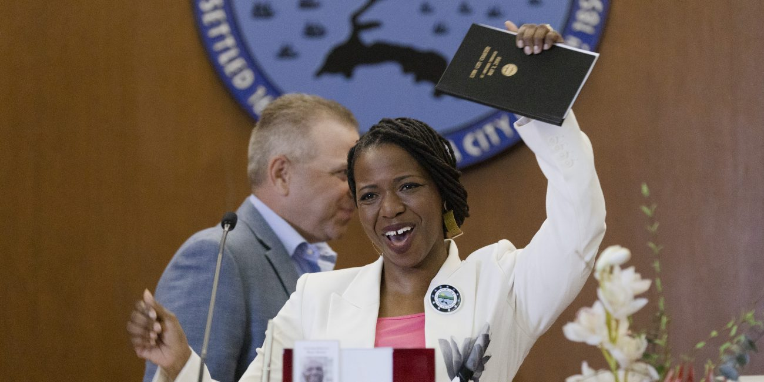Link to Candidate Article
As a Councilor at Large, I serve as a link between residents of Lynn and the local government.
Helping Lynn residents by connecting them to resources, services and city departments.
I also weigh in when top administrators for the city are hired. Passing local ordinance/legislation, and
approving the city budget also encompass my responsibilities.

July 2017 to Present
Founder and President, NORTH SHORE JUNETEENTH ASSOCIATION INC. Lynn, MALink: North Shore Juneteenth Article
North Shore Juneteenth Association is a nonprofit organization dedicated to celebrating, preserving, and sharing the history, culture, and contributions of African Americans within our community. Founded in 2017, the organization began by organizing the first Juneteenth celebration in Lynn, Massachusetts, and has since expanded its programming to include a variety of educational, cultural, and community-centered events.
These events include the Black Excellence 5K, Hats and Heels High Tea, Kid-Friendly Paint Night, educational discussions, cultural exhibits, and other community initiatives designed to promote awareness of the Juneteenth holiday while highlighting the achievements, resilience, and positive contributions of African Americans throughout history and today.

October 2024 – January 2026
Coordinator, Workforce Development
Developed and implemented workforce development programs, built relationships with employers and community partners, and provided comprehensive support to program participants.

December 2023 – May 2024

Coordinator, Lynn Community Enrichment Program
Responsible for planning, coordinating, and delivering educational programming for adult learners

March 2022 – November 2023

director, Salvation Army Smart Center Lynn, Ma. video dance w/students
Marketing, client acquisition, maintain files, curriculum planning, meal planning, bookkeeping, Program planning, supervising a small team, schedule creation

October 2021 – MARCH 2022

Assistant director, bright horizons one financial center
Marketing, client acquisition, maintain files, curriculum planning, meal planning, bookkeeping

July 2019 – To October 2021

Childrens librarian, city of Lynn
Maintain the children’s Dept. Book collection. Collaborate with community organizations to create programming for families of Lynn, Ma. Work with department head to create and organize programming for patrons 0-5 years of age.

Nov. 2018- July 2019
Toddler Teacher, LEO Head Start
Create curriculum, facilitate play and teach children ages 0-5 years old. Engage with parents by answering all questions they might have concerning their child’s day or development, conduct meetings to discuss the development of children in my care.

Aug 2012-Aug 2018
Owner/Operator, rising stars childcare
Marketing, client acquisition, maintain files, curriculum planning, meal planning, bookkeeping, relationship building with other organizations such as Yours for Children, Catholic Charities Lynn, Ma., Aspire, and fellow home-based childcare providers.

Aug 1998 – April 2009
Military service, united states army national guard
I worked as an automated logistical specialist during my time in the military. The Automated Logistical Specialist is primarily responsible for supervising and performing management or warehouse functions to maintain equipment records and parts.

Education

MASTER’S degree Received may 2024

educational leadership & Policy, Boston college

BACHELOR’S Degree received NOVEMBER 2012

EARLY CHILDHOOD EDUCATION, ASHFORD UNIVERSITY

June 2006

Paraeducator, north Shore Community college

References upon request

